Project Executable Files

Date | 2 July 2026
Team ID | SWTID-2026-3658
Project Name | EduGenie Google Gemini Powered Learning Assistant
Maximum Marks | 3 Marks

Project Executable Files
This section includes all the executable and deployable files required to run the EduGenie project successfully. The project is organized with a modular FastAPI backend, Jinja2 frontend, SQLite database, and AI integrations using Google Gemini 1.5 Flash and LaMini-Flan-T5.

Step 1: Submission Checklist

S.No | Item to Submit | Submitted (Yes / No / NA)
1 | Complete source code (all files and folders) | Yes
2 | README / Setup Guide (instructions to run the project) | Yes
3 | requirements.txt / package.json / dependency file | Yes
4 | Database schema / seed files (if applicable) | Yes
5 | Environment configuration file (.env.example or similar) | Yes
6 | Deployed application URL (if hosted) | Yes
7 | APK / Executable binary (if applicable for mobile/desktop apps) | NA
8 | Dockerfile / Containerization config (if applicable) | No
9 | Test files and test results | Yes
10 | Demo video or walkthrough (if required) | Yes

Step 2: File / Folder Structure
Provide an overview of your project's file and folder structure below:

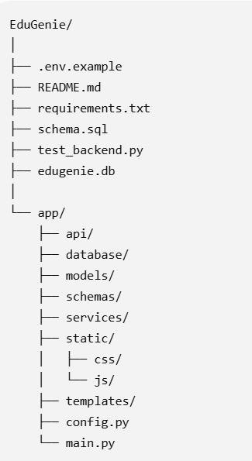

Step 3: Deployment / Access Details

Field | Details
Hosted / Deployed URL | edugenie
Login Credentials  (Demo) | UserName : Krishna  Email : krishna9@gmail.com  Password : krishna
Platform / Hosting  Provider | Render
Repository Link | github/Gayathritata/EduGenie.git
Demo Video Link

Step 4: Run Instructions
Provide clear, step-by-step instructions for the evaluator to run your project locally:

Pre-requisites
- Python 3.10 or above
- Internet connection (for AI API access)
- Google Gemini API Key
- Hugging Face API Key (optional for LaMini)

Steps
Step 1: Clone the repository.
git clone <repository-url>
Step 2: Create and activate a virtual environment.
python -m venv venv
Step 3: Install the dependencies.
pip install -r requirements.txt
Step 4: Configure the environment.
Copy .env.example to .env
Add GEMINI_API_KEY
Add HF_API_KEY
Step 5: Run the application.
python -m uvicorn app.main:app --reload
Step 6: Open the application.
Frontend:
http://127.0.0.1:8000/

Swagger API:
http://127.0.0.1:8000/docs

Step 5: Known Issues / Limitations

S.No | Known Issue / Limitation | Workaround / Status
1 | AI response time depends on external API latency. | Retry the request or ensure a stable internet connection.
2 | SQLite is suitable for local development but not large-scale deployment. | Planned migration to PostgreSQL in future versions.
3 | Document upload and Retrieval-Augmented Generation (RAG) are not yet implemented. | Planned as a future enhancement using ChromaDB/FAISS.

